Group Activity 3 | - ITEC 570 SPRING 2024

Turn in after class.

Ahmed Altouqi
ITEC 570-001
Relationship Indicators to  Use with Crow’s foot notation | 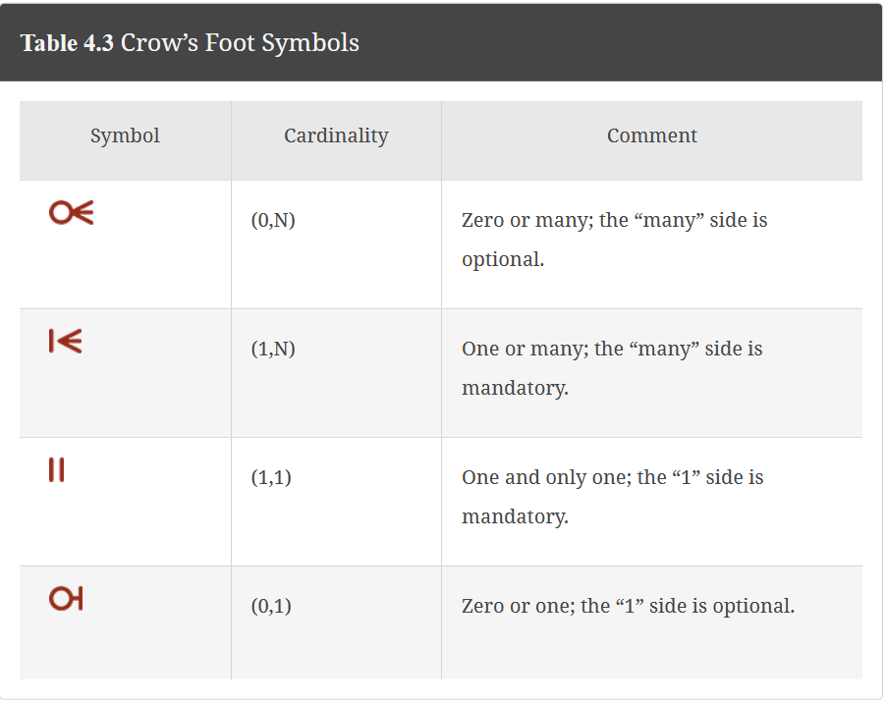
Many-to-many | No many to many relationships are allowed!  To eliminate many to many, create a junction/bridging entity/table with composite primary key.
ER-models and ERD | Hand drawn models will be given a zero.  You must use Draw.io, diagram.net or visio  Label your models  Include your name, itec 570, data model #, title  ER-model only displays two entities and relationships.  ERD displays all entities, attributes, relationships, PK and FK  Indicate the PK in bold and underlined.  Indicate FK in bold in red font.
Embed ER-models and ERD into this document.
- YouTube
- Hulu
- Netflix
- Twitch
- Other __________________________________________
Turn-in the following.

- Which website did you choose?
YouTube

- Summary of the content found on this website.
YouTube is a video-sharing platform where users can upload, watch, and interact with a wide variety of content. It has billions of users globally and offers features like channels, subscriptions, and monetization options for creators. YouTube has significantly impacted internet culture and entertainment, becoming a dominant force in online video consumption.

- Can you identify data that is presented to the user?(Already stored-SELECT statements)
  - Use screen shots to help communicate data identified.
  - You do not have to collect all attributes at this level.
  - Entity- the concepts of metadata for the website and metadata for the user logged on.
  - Note how entities are related.
  - Note business rules that you can determine from the functionality of the website.

Data Identified:
- Video Title
- Video Channel Name
- Upload Date
- View Count
- Like/Dislike Count

Entities:
- Video
- Channel

Relationships:
- A Channel uploads many Videos.
- A Video belongs to one Channel.

Business Rules:
- Users must be logged in to upload videos.
- Videos cannot exceed a certain length.
- Videos must comply with YouTube's community guidelines.

- Data collected for each user.(Insert,Update or Delete)
  - Same instructions as 3 a-d. You should find new data not mentioned in 3 a-d.

Data identified includes username, profile picture, subscriptions, watch history and liked videos (based on user profile).
So entities would be user, channel, subscriptions, history and liked videos

Relationships:
- A User can have one Channel.
- A User subscribes to many Channels. (Many-to-Many relationship)
- A User has a Watch History of Many Videos. (Many-to-Many relationship)
- A User likes many Videos. (Many-to-Many relationship)

Business Rules:
- Users can control the privacy of their watch history and liked videos.
- Users can manage their subscriptions.

Next sketch an ER-model of at least 5 entities identified from your analysis of the commercial website above.
If you identified attributes, include those also. Include the relationships. You may also describe ER-model with business rules.



